**Chapter-1: Introduction**

**Introduction:**

Medical Image Processing has been a popular field for the research and project purpose these days. When talking about Tumor Extraction or the similar area, it has been noticed that the research is extremely active in the image processing of human brain for the successful tumor detection and analysis. Although, it becomes a challenge to rectify the critical examination of medical brain images, the newest technology and its capabilities pulls it through. In this Final Year Research Project, we have gathered main focus on the methodology which tends the automation of analysis regarding brain tumor to become effectively possible. For this, we are up to utilize the latest A.I technology followed by its revolutionary technique, Deep Learning. The data for the Tumor Detection consists of MR images of brain, halve of them containing tumor traces while others do not. After the completion of back-end process, it is all about the User Interface design that would be accomplished through developing an Android & iOS Application while applying all the back-end methodologies behind it. This application has been planned to be named as “Tumaria”.

As our Final Year Project is on one of the most demanding domain of this era, i.e. Artificial Intelligence. The centre of attention in our project is towards the advancement in the field of Tumor Pathology in the human brain. In this project, we shall use the MRI images of the brains, half of them containing tumor, while others do not. For the related research and implementation, we are up to use one of the best and renowned Neural Network Algorithm, i.e. Convolutional Neural Network (CNN). Moreover, all the work is aimed to be done using the Python Language. For the usability of the system, there would be a proper Android and iOS Mobile Application which would be linked with an API containing our MR images’ trained model. In the end, we can say that the project is a perfect combo of front-end and back-end, giving prestige to the revolutionary technologies of Artificial Intelligence as well as Flutter UI Software Development.

* 1. **Background:**

A brain tumor is a mass or growth of abnormal cells in your brain. It has different types and varying effects on the human body. Some brain tumors are benign i.e. they are non-cancerous while some are malignant i.e. they contain cancer. Generally, brain tumors arises in two different modes. A primary brain tumor originates initially in a human brain, whereas the secondary brain tumor (metastatic) is caused due to cancer present in other parts of your body. How quickly a brain tumor grows can vary greatly. The growth rate as well as location of a brain tumor determines how it will affect the function of your nervous system.

Primary brain tumors begin when normal cells acquire errors (mutations) in their DNA. These mutations allow cells to grow and divide at increased rates and to continue living when healthy cells would die. The result is a mass of abnormal cells, which forms a tumor.

Secondary (metastatic) brain tumors are tumors that result from cancer that starts elsewhere in your body and then spreads to your brain. Any cancer can spread to the brain, but the most common types include, Lung Cancer, Kidney Cancer, Breast Cancer, etc.

Moreover, there are two common factors due to which brain tumor can take place. One of them is exposure to radiations as these can be harmful to the entire body. The second factor is family history of genetic syndromes that increase the risk of brain tumors.

* 1. **Problem Statement:**

Detecting tumor in the complex and delicate organs of the human body is always a big challenge. For the tumor in human brain, the doctors and specialists have to go through deep examination of the MRI or the CT-scanned image. This surely takes too much time to get to some final conclusion. Even a tiny spot can make difference if got ignored. Through the automation process and brain tumor detection application, it would be far easier to execute the brain tumor examination.

* 1. **Objectives Of Study:**
* To contribute in the field of human brain pathology through developing an effective and automated tool in order to detect human brain tumor.
* Automatically detect brain tumor by MR images of a patient’s brain.
* To create such an interface for the brain tumor detection system which is understandable and easily operable.
  1. **Significance and Limitations:**

Artificial Intelligence has turned out to be the best guardian for the field of medical. In order to carry out different image segmentations through its sophisticated methods, Artificial Intelligence has deployed a remarkable change for the surgeries that require image guidance. As in this project, we are focusing on the brain tumor analysis and detection, the deep learning models and image segmentation techniques shall make it possible to accomplish the needs in an efficient way, thus converting the manual image analysis into effective and improved automation.

It is obvious that when we work on a certain project, there are some limitations and hurdles that can put effect in our workflow and project goals. In this project, we are facing the following:

* + Limited number of dataset will be used for the project.
  + The proposed model will be justified only through the Python language.

**Chapter-2: Literature Review**

**Chapter-3: Project Methodology**

* 1. **Crisp-DM-Model:**

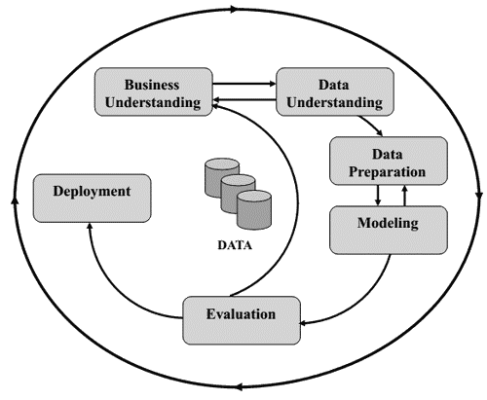

**3.1.1. Proposed Project:**

**Chapter-4: Design And Tools**

**4.1. Project Design (Fully dressed UML and Flowchart):**

* **Fully Dressed Use Case:**

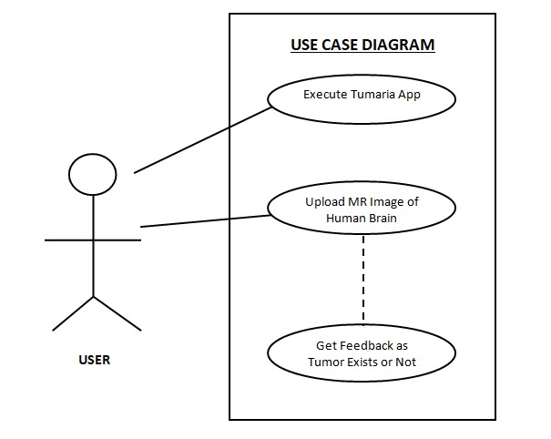

* **Flowchart:**

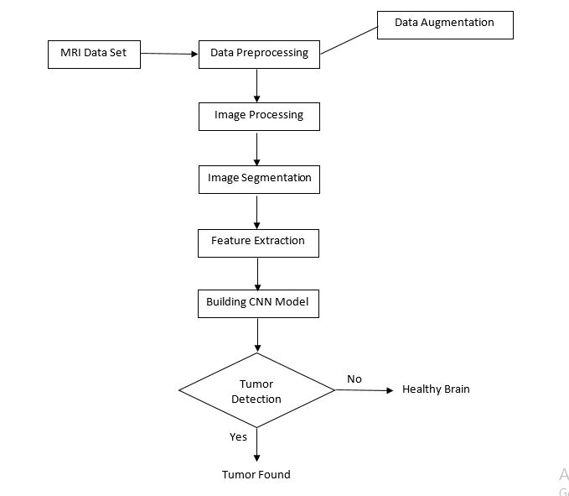

* 1. **Tools and Techniques:**

**Chapter-5: Timeline And Conclusion**

* 1. **Gantt Chart:**

|  |  |  |  |  |  |  |  |  |  |  |  |
| --- | --- | --- | --- | --- | --- | --- | --- | --- | --- | --- | --- |
| **Task Description** | **FYP 1** | | | | | | **FYP 2** | | | | |
| **Feb 2021** | **Mar**  **2021** | **Apr**  **2021** | **May 2021** | **Jun 2021** | **Jul 2021** | **Aug 2021** | **Sep 2021** | **Oct 2021** | **Nov 2021** | **Dec 2021** |
| **Planning** |  |  |  |  |  |  |  |  |  |  |  |
| **Research** |  |  |  |  |  |  |  |  |  |  |  |
| **FYP-01 Report** |  |  |  |  |  |  |  |  |  |  |  |
| **Implementation** |  |  |  |  |  |  |  |  |  |  |  |
| **Testing** |  |  |  |  |  |  |  |  |  |  |  |
| **Follow up** |  |  |  |  |  |  |  |  |  |  |  |

* 1. **Conclusion:**